

API Guide

Trouble Ticket

February 2018

Disclaimer

This API Guide describes a set of APIs that may be implemented on one or more Interface Reference Points (IRPs) of the LSO Reference Architecture, as defined in MEF 55. THIS API GUIDE IS NOT A MEF SPECIFICATION. THEREFORE THIS API GUIDE AND ITS CONTENTS ARE NOT SUBJECT TO THE PATENT LICENSING COMMITMENTS FOR FINAL SPECIFICATIONS CONTAINED IN THE INTELLECTUAL PROPERTY RIGHTS POLICY PROVISIONS OF MEF’S BYLAWS.

Implementation of this API Guide may require use of patents or proprietary technology owned by third parties, including MEF Members and non-Members. MEF makes no representations or warranties as to the existence or absence of patent rights that read on this API Guide or its contents. MEF is not under any obligation to and has not undertaken to perform or conduct a patent search.

The information in this publication is freely available for reproduction and use by any recipient and is believed to be accurate as of its publication date. Such information is subject to change without notice and MEF Forum (MEF) is not responsible for any errors. MEF does not assume responsibility to update or correct any information in this publication.

This API Guide and its contents are provided “as is,” with no representation or warranty, expressed or implied, including without limitation implied warrantIES OF NON-INFRINGEMENT OR fitness for a particular PURPOSE. WITHOUT LIMITING THE GENERALITY OF THE FOREGOING, MEF DOES NOT REPRESENT OR WARRANT THE COMPLETENESS, ACCURACY, OR APPLICABILITY OF ANY INFORMATION CONTAINED HEREIN, AND NO LIABILITY OF ANY KIND SHALL BE ASSUMED BY MEF AS A RESULT OF RELIANCE UPON OR IMPLEMENTATION OF SUCH INFORMATION.

The information contained herein is intended to be used without modification by the recipient or user of this document. MEF is not responsible or liable for any modifications to this document made by any other party.

The receipt or any use of this document or its contents does not in any way create, by implication or otherwise:

(a) any express or implied license or right to or under any patent, copyright, trademark or trade secret rights held or claimed by any MEF member which are or may be associated with the ideas, techniques, concepts or expressions contained herein; nor

(b) any warranty or representation that any MEF member will announce any product(s) and/or service(s) related thereto, or if such announcements are made, that such announced product(s) and/or service(s) embody any or all of the ideas, technologies, or concepts contained herein; nor

(c) any form of relationship between any MEF member and the recipient or user of this document.

Implementation or use of if this API Guide is optional, and no Member shall be obliged to implement them by virtue of participation in MEF Forum. MEF is a non-profit international organization to enable the development and worldwide adoption of agile, assured and orchestrated network services. MEF does not, expressly or otherwise, endorse or promote any specific products or services.

© MEF Forum 2018. All Rights Reserved.

Table of Contents

1. List of Contributing Members 1

2. Abstract 1

3. Scope 1

4. Trouble Ticket Resource model 2

5. State Diagrams 3

6. Notifications 4

6.1 Subscribe to notification: 4

6.2 Receive Notification: 5

7. JSON Representation Sample 6

8. API Operations 7

8.1 Create Trouble Ticket 8

8.2 Retrieve Trouble Tickets 10

8.3 Retrieve a single trouble ticket by ticket identifier 12

8.4 Update Trouble Ticket 12

List of Figures

Figure 1 Trouble Ticket Resource Model 2

Figure 2 Trouble Ticket State Machine 3

List of Tables

Table 1 Contributing Member Companies 1

Table 2 Mapping UC – API operations 7

# List of Contributing Members

The following member of MEF participated in the development of this document and have requested to be included in this list.

|  |  |
| --- | --- |
| AT&T | Orange |
| Cataworks | Telus |
| Colt |  |
|  |  |

Table Contributing Member Companies

# Abstract

This API Guide is intended to help companies to implement the MEF Trouble Ticket Management API. The API swagger is available on MEF GitHub. In order to help API adoption this document provides:

* API Resource Model
* Resource Trouble Ticket lifecycle
* Resource Trouble Ticket full representation
* Detailed description of all API Operations provided

# Scope

The scope of the project for the initial release is the ability for a Service Provider’s system to create and manage trouble tickets with Partner’s system, over an interface, related to Access E-Line products. The following operations are included in the scope of this project:

* Create a new trouble ticket
* Retrieve an existing trouble ticket(s)
* Partial modification of an open trouble ticket
* Close an open trouble ticket
* Cancel an open trouble ticket
* Trouble ticket related notifications.

Specifically, out of scope for this release are the following operations:

* Scheduled Maintenance & Outages related notifications and management.

# Trouble Ticket Resource model

The API Trouble Ticket resource model is the following:

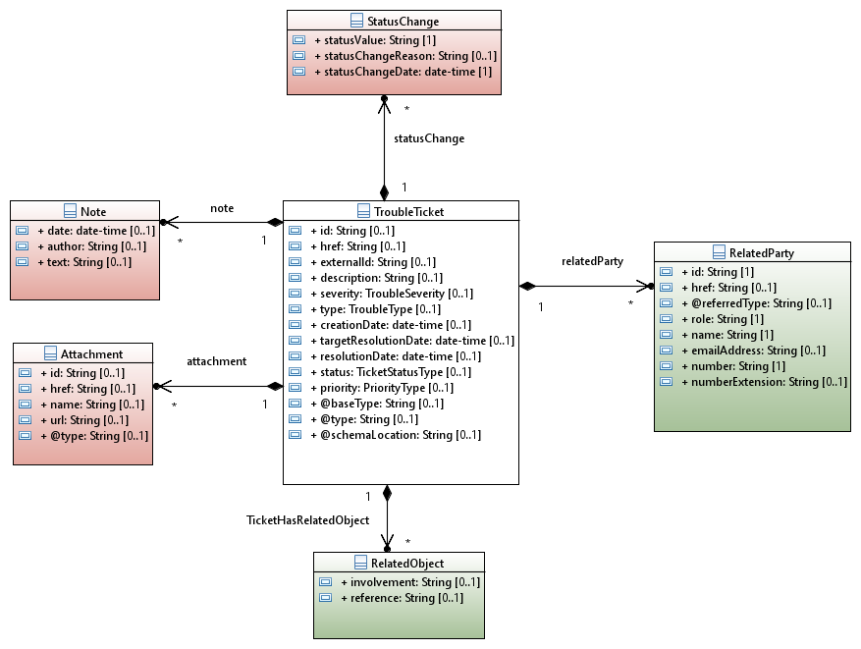

Figure Trouble Ticket Resource Model

**Color coding scheme:**

* White box: API main resource
* Pink box: API sub resource(s)
* Green box: API related/referred resource(s)

# State Diagrams

Following diagram shows the state machine for a Trouble Ticket:

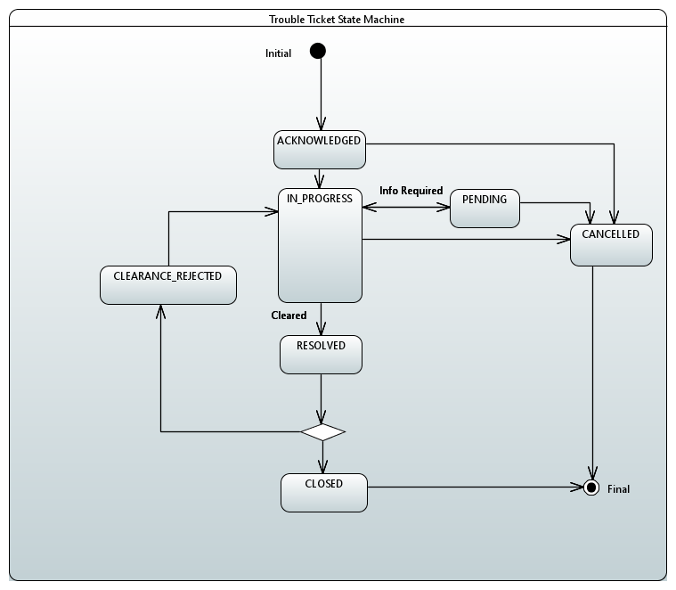

Figure Trouble Ticket State Machine

# Notifications

The following notifications are managed in this API:

* TicketStateChangeNotification
* TicketUpdateNotification
* TicketClearanceRequestNotification
* TicketInformationRequiredNotification

In order to receive Notifications, the Service Provider needs

* to subscribe to a notification
* to provide an Event API in order to allow the Partner to post notifications

## Subscribe to notification:

By doing the following request Service Provider will subscribe to trouble ticket state changes:

POST {api_url}/HUB

Accept: application/json

{"callback": <http://in.listener.com>,

“query”:”eventType = TicketStateChangeNotification”

}

In yellow, this is the address where the Service Provider wants to receive the ticket state change notifications.

The response will be:

201

Content

-

Type:

application/json

Location: /api/hub/42

{"id":"42","callback":"<http://in.listener.com>","query":”eventType = TicketStateChangeNotification”}

Note: 42 is the id of an HUB resource not a trouble ticket id.

The Partner provides GET and DELETE operations on HUB resources in order to allow the Service Provider to retrieve his hub and delete them if necessary:

GET {api_url}/HUB

Accept: application/json

You will have a list of your HUB on this API

[

  {

    "id": "42",

    "query": " eventType = TicketStateChangeNotification",

    "callback": " <http://in.listener.com> "

  },

  {

    "id": "56",

    "query": " eventType = TicketUpdateNotification",

    "callback": " <http://in.listener.com> "

  }

  {

    "id": "72",

    "query": " eventType = TicketClearanceRequestNotification",

    "callback": " <http://in.listener.com> "

  }

{

    "id": "88",

    "query": " eventType = TicketInformationRequiredNotification",

    "callback": " <http://in.listener.com> "

  }

]

If the Service Provider does not want to receive any more notifications for trouble ticket updates:

DELETE {api_url}/HUB/56

Accept: application/json

## Receive Notification:

Now that the Service Provider has subscribed to notifications for trouble ticket state changes for example, let’s suppose that he posted a trouble ticket and this one is processed by the Partner. The trouble ticket state changes. The Partner will POST an Event to the Service Provider:

POST {callback}/event

{

"eventType": " TicketStateChangeNotification",

"eventTime": "2017-09-27T05:46:25.0Z",

"eventId": "92445",

"event":

{

"troubleTicket": {

“id”: “24”

(all trouble ticket attributes including...)

“status”: “RESOLVED”

}

}

The Service Provider will respond with a standard HTTP 201 if the event is received.

# JSON Representation Sample

Example of the JSON representation of a trouble ticket:

{

"id": "62",

"href": "www.mef.att.com/troubleTicketManagement/62",

"externalId": "T-Mobile-EU-BOA-02",

"description": "T-Mobile has raised the ticket on its customer Bank of America's circuit.",

"severity": "CRITICAL",

"type": "FAILURE",

"creationDate": "2018-02-02T18:40:23.283Z",

"targetResolutionDate": "2018-02-04T18:40:23.283Z",

"resolutionDate": "",

"status": "IN_PROGRESS",

"relatedParty": [

{

"id": "13",

"role": "Originator",

"name": "Joe Blau",

"emailAddress": "jb3434@tmz.com",

"number": "932-883-8723",

}

],

"priority": "HIGH",

"relatedObject": [

{

"involvement": "ProductInventory",

"reference": "34"

}

],

"statusChange": [

{

"statusValue": "ACKNOWLEDGED",

"statusChangeReason": "Initial state",

"statusChangeDate": "2018-02-02T18:41:23.283Z"

},

{

"statusValue": "IN_PROGRESS",

"statusChangeReason": "Technician assigned and Changed from ACKNOWLEDGED",

"statusChangeDate": "2018-02-02T19:41:23.283Z"

}

],

"note": [

{

"date": "2018-02-02T21:41:23.283Z",

"author": "Liz Lamar",

"text": "The Test failed indicating a potential fiber cut."

}

],

"attachment": [

{

"id": "2",

"name": "SLA Agreement",

"@type": "PDF"

}

],

"@type": "MEFTroubleTicket",

"@schemaLocation": "http://www.mef.net/sonata/TroubleTicket"

}

# API Operations

In the following table, the use cases and operations defined in the IPS are mapped to the API operations:

|  |  |  |  |
| --- | --- | --- | --- |
| Use Case | Operation | Uniform API Operation | Description |
| UC_SONATA_TROUBLE_0001 | Trouble Ticket Create | POST | Creation of a trouble ticket. |
| UC_SONATA_TROUBLE_0002 | Trouble Ticket Find | GET | Retrieval of trouble ticket(s) without an id but with criteria |
| UC_SONATA_TROUBLE_0003 | Trouble Ticket Get | GET | Retrieval of a trouble ticket with an id |
| UC_SONATA_TROUBLE_0004 | Trouble Ticket Update | PATCH | Partial update of a trouble ticket |
| UC_SONATA_TROUBLE_0005 | Ticket Clearance Request Notification | No operation | Notification sent to indicate a request to clear a trouble ticket |
| UC_SONATA_TROUBLE_0006 | Close Trouble Ticket | PATCH | Update request sent with “requestedStatus” set to “CLOSED”, or “CLEARANCE_REJECTED” |
| UC_SONATA_TROUBLE_0007 | Cancel Trouble Ticket | PATCH | Update request sent with “requestedStatus” set to “CANCELLED” |
| UC_SONATA_TROUBLE_0008 | Ticket Information Required Notification | No operation | Notification sent to indicate additional information is required. |
| UC_SONATA_TROUBLE_0009 | Ticket Update Notification | No operation | Notification sent to indicate that an update has occurred on the ticket. |
| UC_SONATA_TROUBLE_0010 | State Change Notification | No operation | Notification sent to indicate that a state change has occurred on the ticket. |

Table Mapping UC – API operations

## Create Trouble Ticket

POST {apiRoot}/troubleTicket

Description

This operation creates a trouble ticket entity

Behavior

Standard 201 response if trouble ticket created

Otherwise:

|  |  |
| --- | --- |
| 400 | Bad Request |
| 401 | Unauthorized |
| 403 | Forbidden |
| 405 | Method Not Allowed |
| 408 | Request Time-out |
| 422 | Unprocessable entity (see below) |

Specific business errors will be encapsulated in HTTP Response 422 Unprocessable entity:

None.

Usage Sample

T-Mobile (Service Provider) is submitting a new trouble ticket on Access E-Line service provided by AT&T (Partner). T-Mobile has raised the ticket on its customer Bank of America's circuit.

Request:

POST {api_url}/troubleTicket

Content-Type: application/json

{

"externalId": "T-Mobile-EU-BOA-02",

"description": "T-Mobile has raised the ticket on its customer Bank of America's circuit.",

"severity": "CRITICAL",

"type": "FAILURE",

"priority": "HIGH",

"relatedParty": [

{

"id": "13",

"role": "Originator",

"name": "Joe Blau",

"emailAddress": "jb3434@tmz.com",

"number": "932-883-8723",

}

],

"relatedObject": [

{

"involvement": "ProductInventory",

"reference": "34"

}

],

"attachment": [

{

"id": "2",

"name": "SLA Agreement",

"@type": "PDF"

}

],

"@type": "MEFTroubleTicket",

"@schemaLocation": "http://www.mef.net/sonata/TroubleTicket"

}

**Response:**

201

{

"id": "62",

"href": "www.mef.att.com/troubleTicket/62",

"externalId": "T-Mobile-EU-BOA-02",

"description": "T-Mobile has raised the ticket on its customer Bank of America's circuit.",

"severity": "CRITICAL",

"type": "FAILURE",

"creationDate": "2018-02-02T18:40:23.283Z",

"targetResolutionDate": "2018-02-04T18:40:23.283Z",

"resolutionDate": "",

"status": "ACKNOWLEDGED",

"relatedParty": [

{

"id": "13",

"role": "Originator",

"name": "Joe Blau",

"emailAddress": "jb3434@tmz.com",

"number": "932-883-8723",

}

],

"priority": "HIGH",

"relatedObject": [

{

"involvement": "ProductInventory",

"reference": "34"

}

],

"statusChange": [

{

"statusValue": "ACKNOWLEDGED",

"statusChangeReason": "Initial state",

"statusChangeDate": "2018-02-02T18:41:23.283Z"

}

],

"attachment": [

{

"id": "2",

"name": "SLA Agreement",

"@type": "PDF"

}

],

"@type": "MEFTroubleTicket",

"@schemaLocation": "http://www.mef.net/sonata/TroubleTicket"

}

## Retrieve Trouble Tickets

GET {apiRoot}/troubleTicket?{filtering}

Description

This operation is used to retrieve ticket(s) corresponding to search criteria. The response will be a trouble ticket summary. All attributes of the trouble ticket could be used as search criteria.

Only the following attributes will be retrieved in the summary view:

* id
* href
* status
* severity
* target resolution date
* resolution date
* priority
* related object

Behavior

* Returns HTTP/1.1 status code 200 if the request was successful

Note: if no trouble tickets match the criteria an empty list is retrieved with a 200 status code (not considered as a fail)

Otherwise:

|  |  |
| --- | --- |
| 400 | Bad Request |
| 401 | Unauthorized |
| 403 | Forbidden |
| 405 | Method Not Allowed |
| 408 | Request Time-out |
| 422 | Unprocessable entity |

Usage Samples

T-Mobile (Service Provider) is retrieving trouble tickets in "IN-PROGRESS" status on Access E-Line service provided by AT&T (Partner).

Request:

GET {api_url}/troubleTicket?status=IN_PROGRESS

Accept: application/json

Response:

200

[

{

"id": "62",

"href": "www.mef.att.com/troubleTicket/62",

"severity": "CRITICAL",

"creationDate": "2018-02-02T18:40:23.283Z",

"targetResolutionDate": "2018-02-06T18:40:23.283Z",

"resolutionDate": "",

"status": "IN_PROGRESS",

"priority": "HIGH",

"relatedObject": [

{

"involvement": "ProductInventory",

"reference": "34"

}

]

},

{

"id": "43",

"href": "www.mef.att.com/troubleTicket/43",

"severity": "MINOR",

"creationDate": "2018-02-01T18:43:23.283Z",

"targetResolutionDate": "2018-02-07T18:56:23.283Z",

"resolutionDate": "",

"status": "IN_PROGRESS",

"priority": "MEDIUM",

"relatedObject": [

{

"involvement": "ProductInventory",

"reference": "76"

}

]

}

]

## Retrieve a single trouble ticket by ticket identifier

GET {apiRoot}/troubleTicket/{id}

Description

This operation is used to retrieve a single trouble ticket.

Behavior

* Returns HTTP/1.1 status code 200 if the request was successful

Otherwise:

|  |  |
| --- | --- |
| 400 | Bad Request |
| 401 | Unauthorized |
| 403 | Forbidden |
| 404 | Not Found |
| 405 | Method Not Allowed |
| 408 | Request Time-out |
| 422 | Unprocessable entity (see below) |

Usage Sample

Request

|  |
| --- |
| GET {api_url}/troubleTicketManagement/troubleTicket/62 Accept: application/json |

Response

See JSON illustrating trouble ticket resource (JSON representation sample §)

## Update Trouble Ticket

PATCH {apiRoot}/troubleTicket

Description

This operation updates a trouble ticket entity. It can be used to update an attribute(s), in particular the “requestedStatus” when the Service Provider wishes to close or cancel an existing trouble ticket.

Behavior

Standard 201 response if trouble ticket successfully updated.

Otherwise:

|  |  |
| --- | --- |
| 400 | Bad Request |
| 401 | Unauthorized |
| 403 | Forbidden |
| 405 | Method Not Allowed |
| 408 | Request Time-out |
| 422 | Unprocessable entity (see below) |

Usage Samples

T-Mobile (Service Provider) is updating an existing trouble ticket on Access E-Line service provided by AT&T (Partner). T-Mobile had raised the ticket on its customer Bank of America's circuit.

Request:

PATCH {api_url}/troubleTicket/62

Accept: application/json

{

"relatedParty": [

{

"id": "13",

"role": "Originator",

"name": "Mary Joe",

"emailAddress": "mb3345@tmz.com",

"number": "932-883-8722",

},

{

"id": "15",

"role": "Reviser",

"name": "Jill Smith",

"emailAddress": "js2345@tmz.com",

"number": "932-883-8422",

}

],

"note": [

{

"date": "2018-02-02T21:41:23.283Z",

"author": "Liz Lamar",

"text": "The Test failed indicating a potential fiber cut."

},

{

"date": "2018-02-04T11:41:23.283Z",

"author": "Jill Smith",

"text": "Originator left the company and replaced relatedParty."

}

],

"@type": "MEFTroubleTicket",

"@schemaLocation": "http://www.mef.net/sonata/TroubleTicket"

}

Response:

200

{

"id": "62",

"href": "www.mef.att.com/troubleTicket/62",

"externalId": "T-Mobile-EU-BOA-02",

"description": "T-Mobile (Service Provider) is retrieving a trouble ticket on Access E-Line service provided by AT&T (Partner). T-Mobile has raised the ticket on its customer Bank of America's circuit.",

"severity": "CRITICAL",

"type": "FAILURE",

"creationDate": "2018-02-02T18:40:23.283Z",

"targetResolutionDate": "2018-02-04T18:40:23.283Z",

"resolutionDate": "",

"status": "IN_PROGRESS",

"relatedParty": [

{

"id": "13",

"role": "Originator",

"name": "Mary Joe",

"emailAddress": "mb3345@tmz.com",

"number": "932-883-8722",

},

{

"id": "15",

"role": "Reviser",

"name": "Jill Smith",

"emailAddress": "js2345@tmz.com",

"number": "932-883-8422",

}

],

"priority": "HIGH",

"relatedObject": [

{

"involvement": "ProductInventory",

"reference": "34"

}

],

"statusChange": [

{

"statusValue": "ACKNOWLEDGED",

"statusChangeReason": "Initial state",

"statusChangeDate": "2018-02-02T18:41:23.283Z"

},

{

"statusValue": "IN_PROGRESS",

"statusChangeReason": "Technician assigned and Changed from ACKNOWLEDGED",

"statusChangeDate": "2018-02-02T19:41:23.283Z"

}

],

"note": [

{

"date": "2018-02-02T21:41:23.283Z",

"author": "Liz Lamar",

"text": "The Test failed indicating a potential fiber cut."

},

{

"date": "2018-02-04T11:41:23.283Z",

"author": "Jill Smith",

"text": "Originator left the company and replaced relatedParty."

}

],

"attachment": [

{

"id": "2",

"name": "SLA Agreement",

"@type": "PDF"

}

],

"@type": "MEFTroubleTicket",

"@schemaLocation": "http://www.mef.net/sonata/TroubleTicket"

}